DESIGN of SEQUENTIAL CIRCUITS

Design procedure
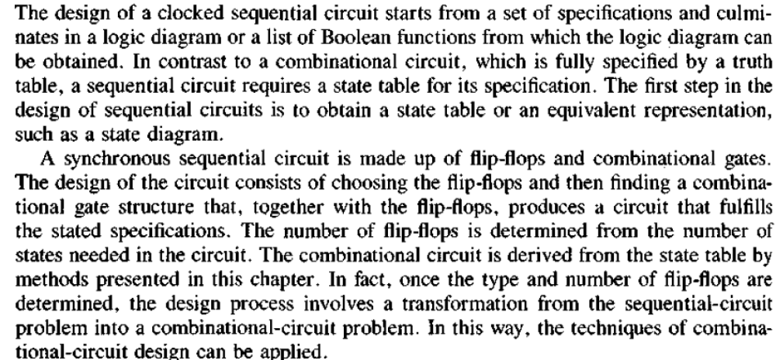
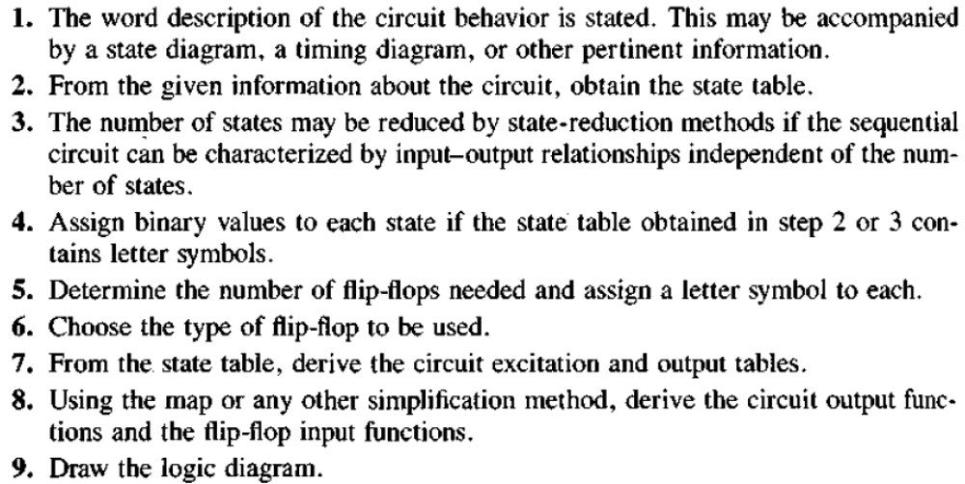
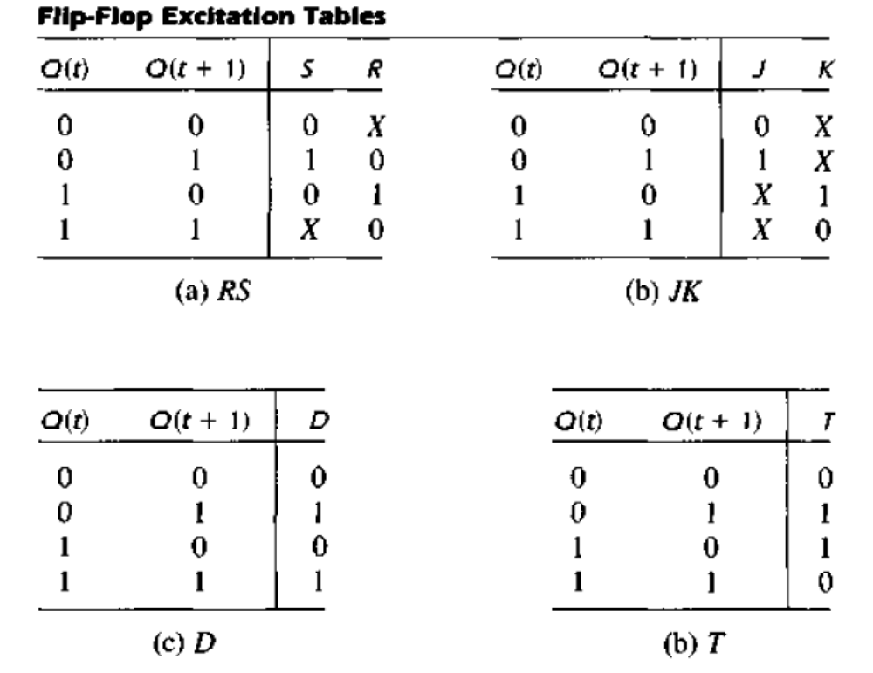
FLIP-FLOP NAME | FLIP-FLOP SYMBOL | CHARACTERISTIC TABLE | CHARACTERISTIC EQUATION | EXCITATION TABLE
SR | 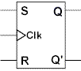 |  | Q(next) = S + R'Q  SR = 0
  S | R | Q(next)
  0 | 0 | Q
  0 | 1 | 0
  1 | 0 | 1
  1 | 1 | ?
  Q | Q(next) | S | R
  0 | 0 | 0 | X
  0 | 1 | 1 | 0
  1 | 0 | 0 | 1
  1 | 1 | X | 0
JK | 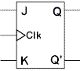 |  | Q(next) = JQ' + K'Q
  J | K | Q(next)
  0 | 0 | Q
  0 | 1 | 0
  1 | 0 | 1
  1 | 1 | Q'
  Q | Q(next) | J | K
  0 | 0 | 0 | X
  0 | 1 | 1 | X
  1 | 0 | X | 1
  1 | 1 | X | 0
D | 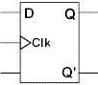 |  | Q(next) = D
  D | Q(next)
  0 | 0
  1 | 1
  Q | Q(next) | D
  0 | 0 | 0
  0 | 1 | 1
  1 | 0 | 0
  1 | 1 | 1
T | 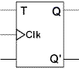 |  | Q(next) = TQ' + T'Q
  T | Q(next)
  0 | Q
  1 | Q'
  Q | Q(next) | T
  0 | 0 | 0
  0 | 1 | 1
  1 | 0 | 1
  1 | 1 | 0

Example: sequence detector

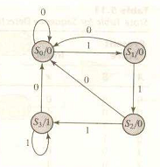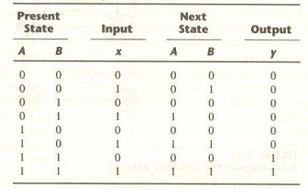

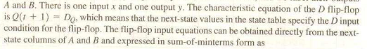
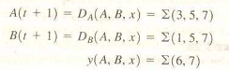
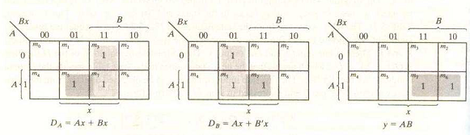
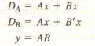

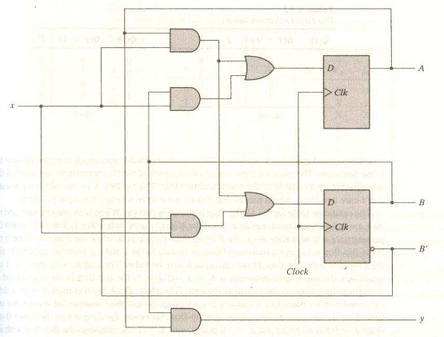
JK-flip-flop
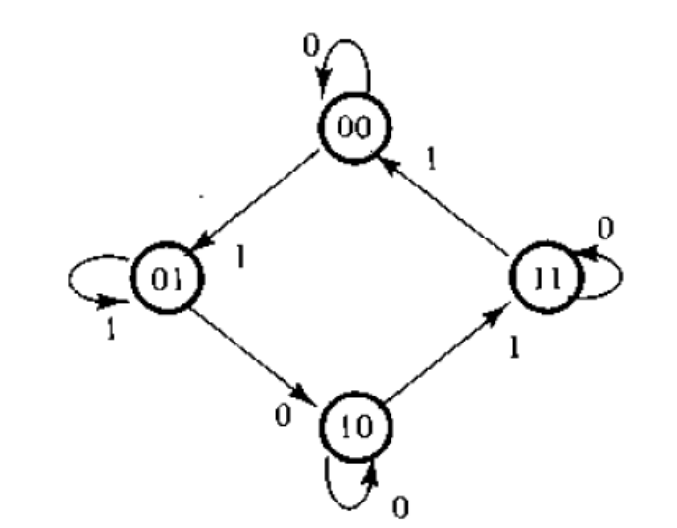
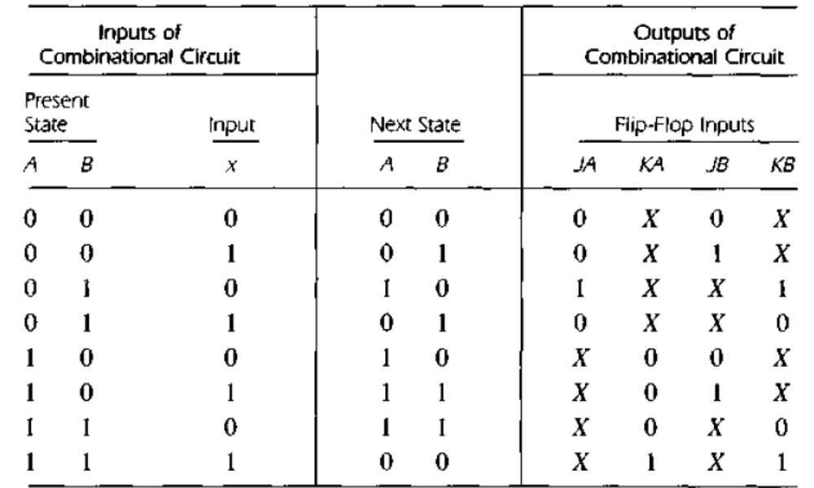

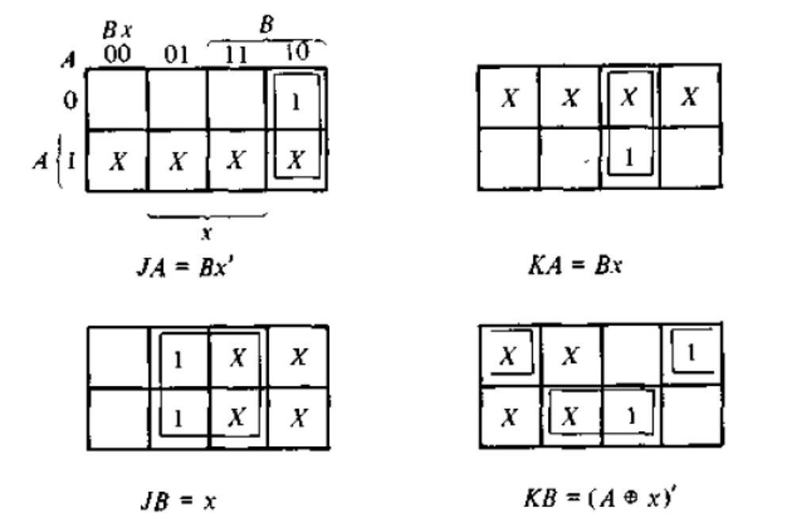
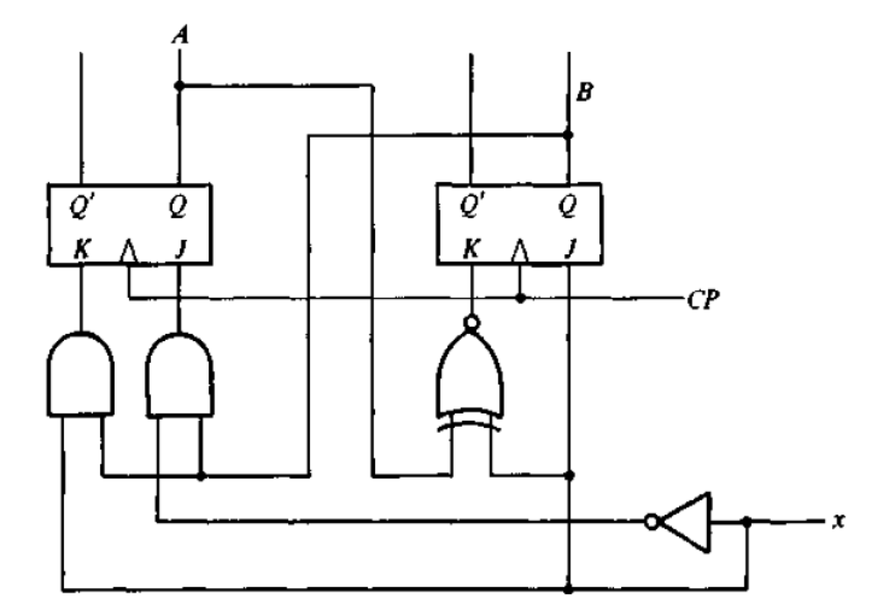


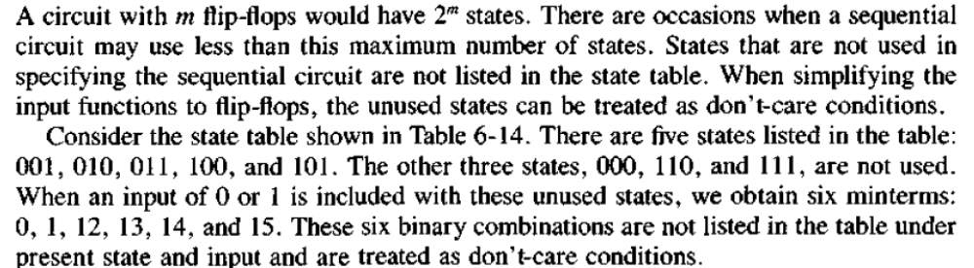
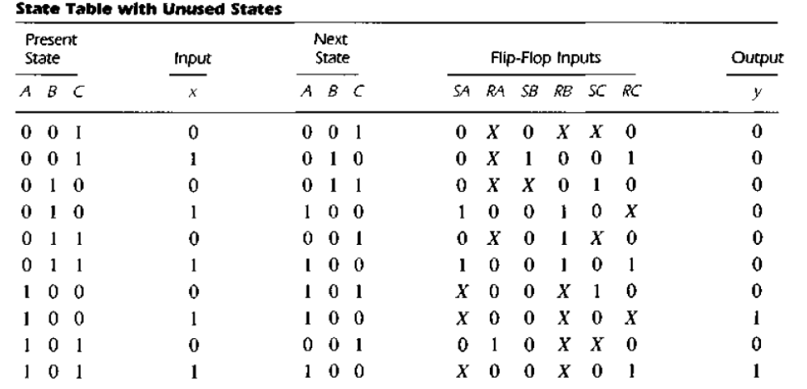
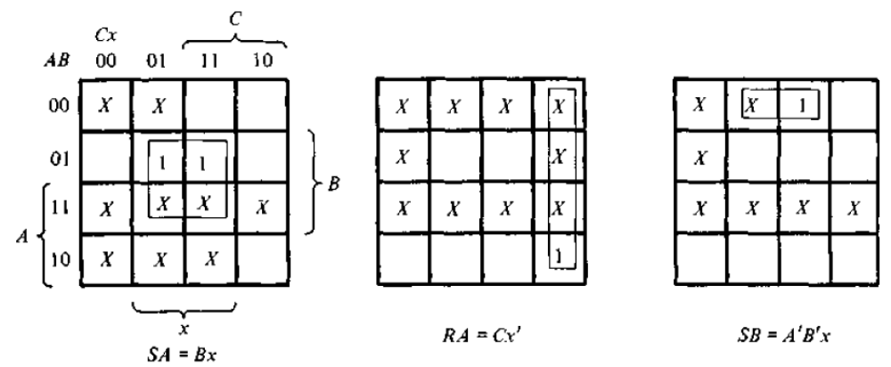
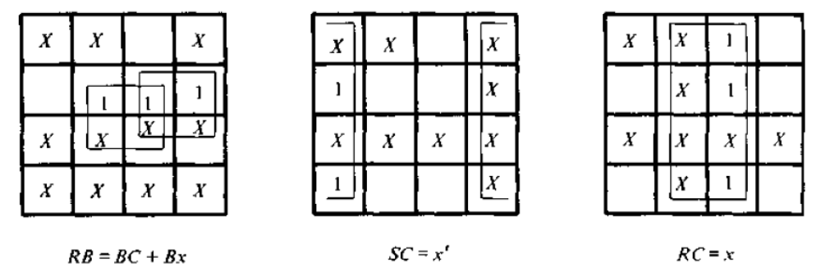
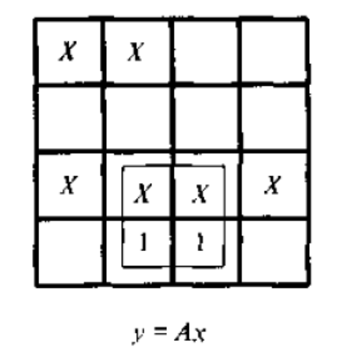
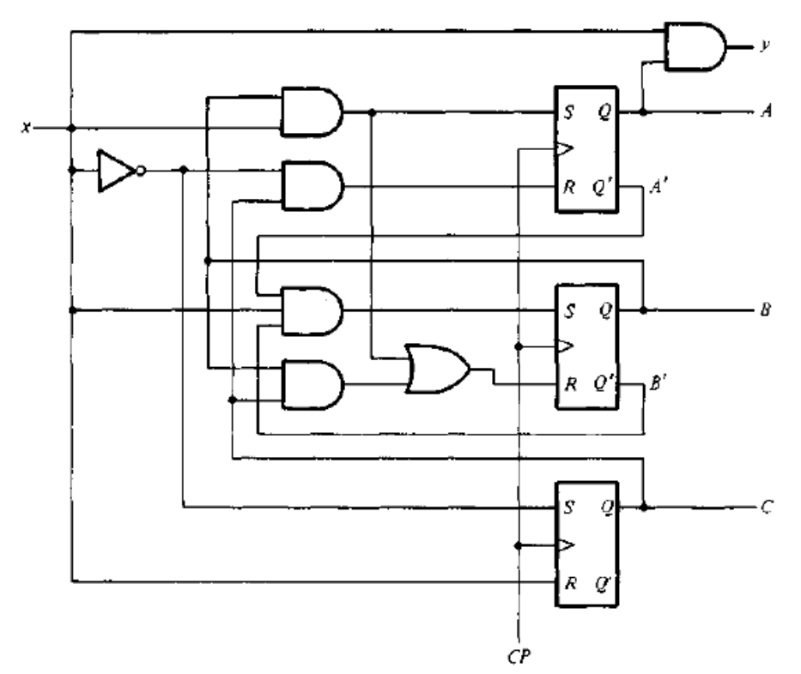
Investigation of unused states must be performed.
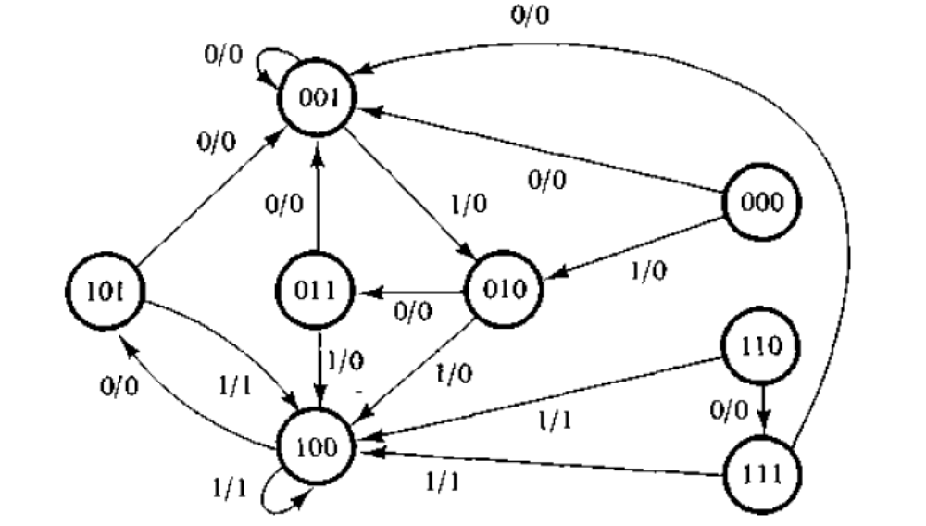

Design of counters
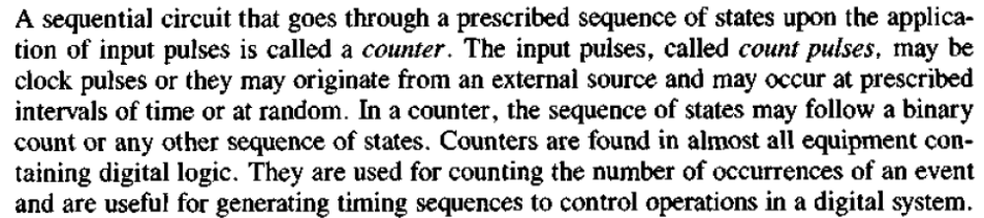
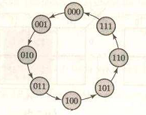
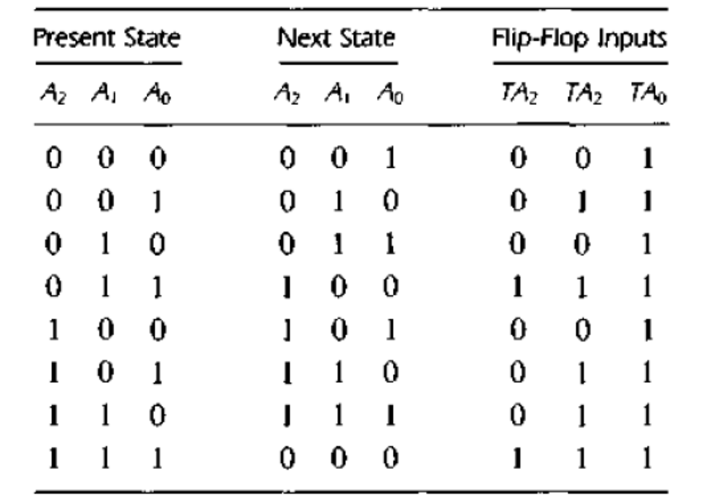
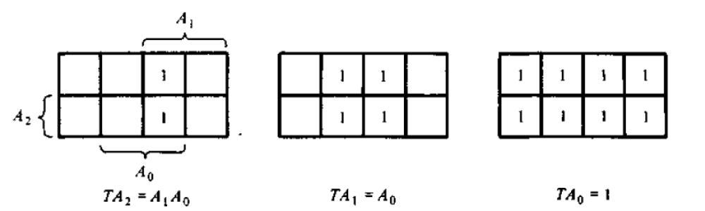

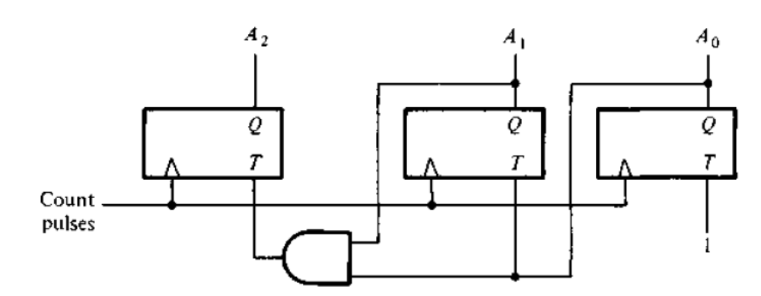
Design the counter which counts 0,1,2,4,5,6.
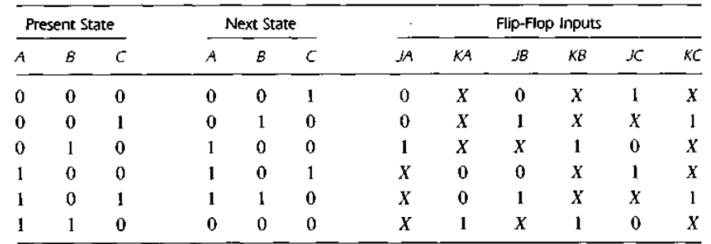
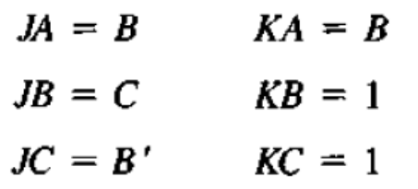
m3 and m7 are don’t-care conditions.
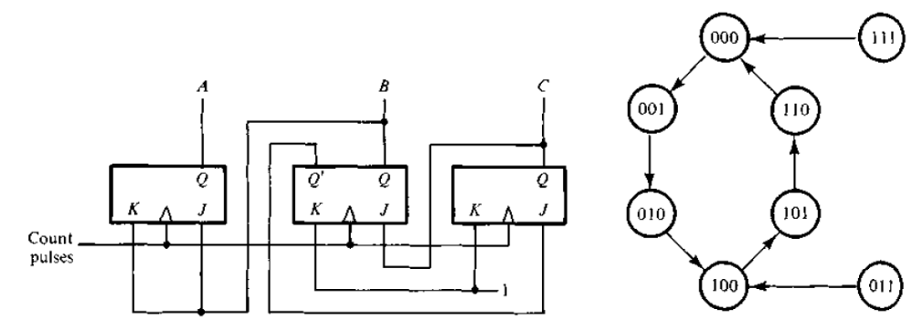
Investigation of unused states must be performed.

State reduction
